EXERCISE NO. : 9

CLOSED LOOP PNEUMATICS

PID CONTROLLERS

DATE:

Reg. No. :

**LAB PREREQUISITES:**

None

**PREREQUISITE KNOWLEDGE:**

Fundamentals of Festo FluidSIM.

**OBJECTIVES:**

* Understand the basics of PID Controllers
* Understand the PID controller hardware in the laboratory
* To set the parameters of PID controller using an empirical method
* To assess the transient response of a closed loop circuit with a PID controller

**THEORY**

**Key Information related to Festo PID Controller:**

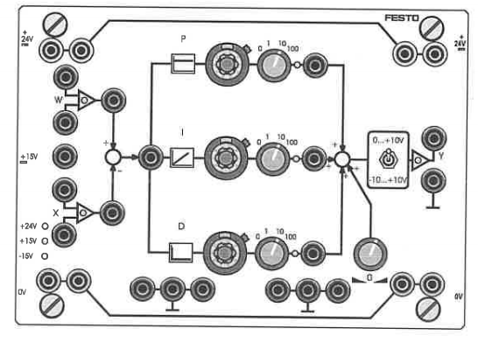

Range Selector Switch

Correcting Variable Offset

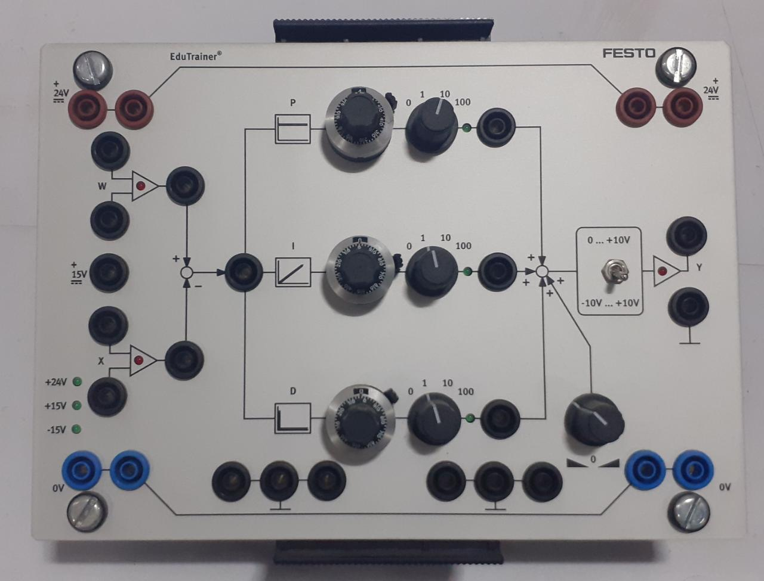

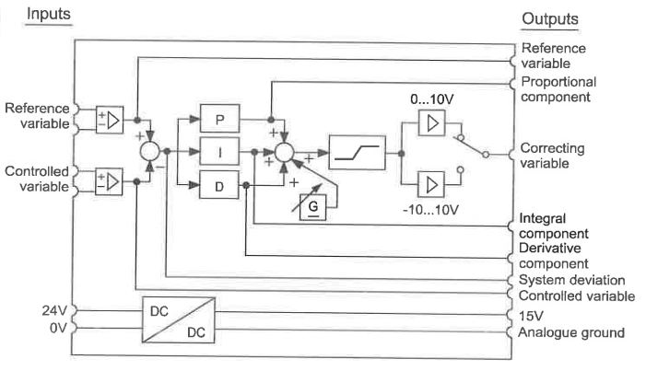

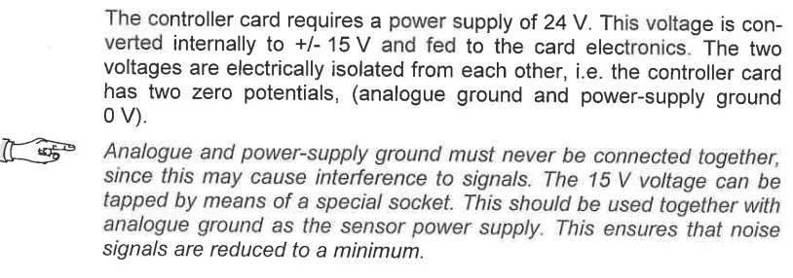

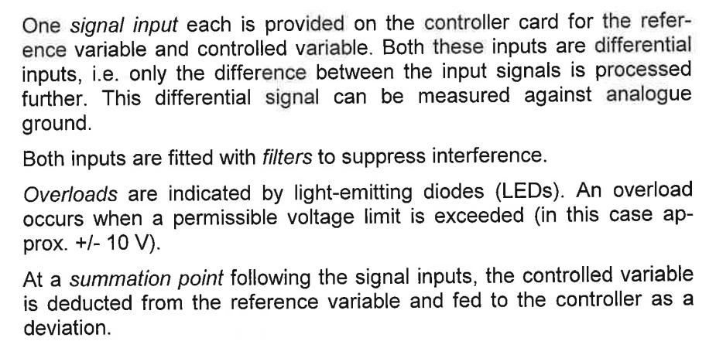

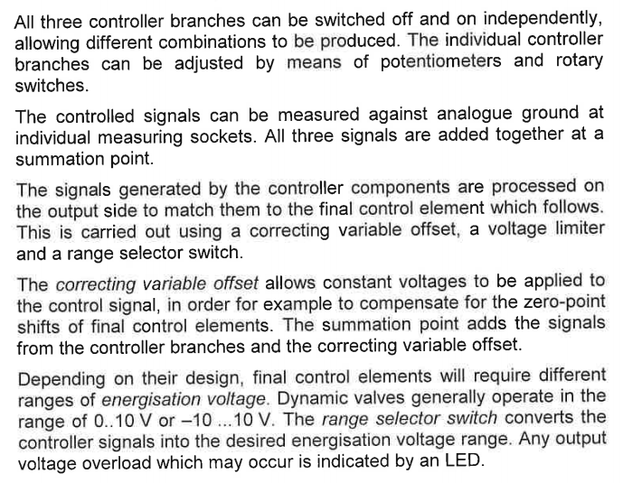

**BASICS OF PID CONTROLLER**

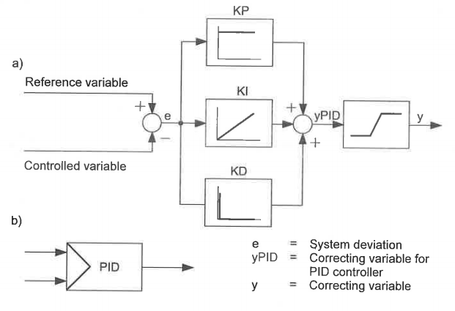

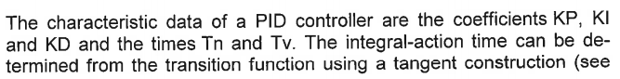

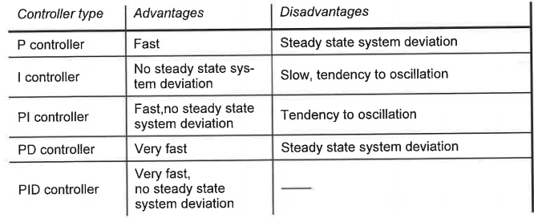

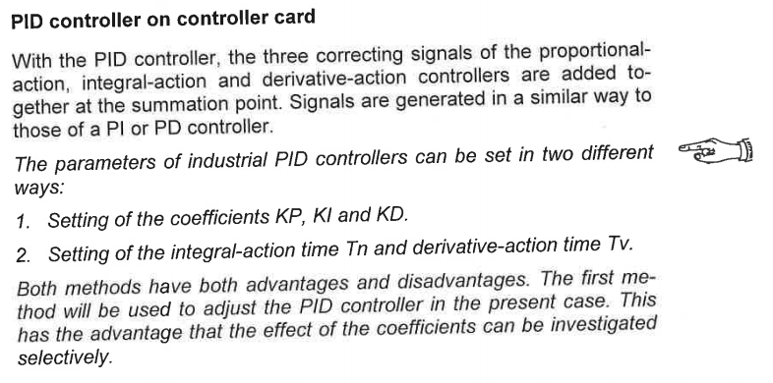

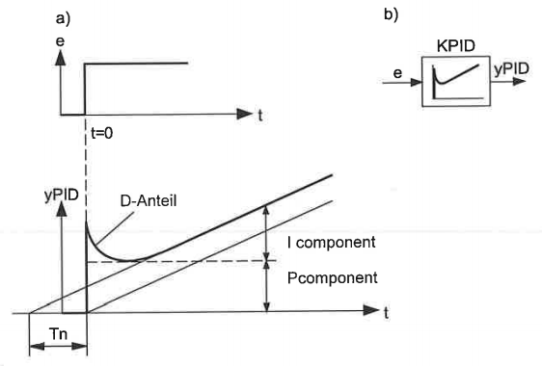

**EMPIRICAL PARAMETERIZATION OF A PID CONTROLLER**

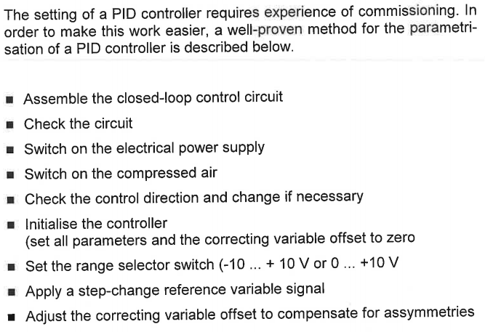

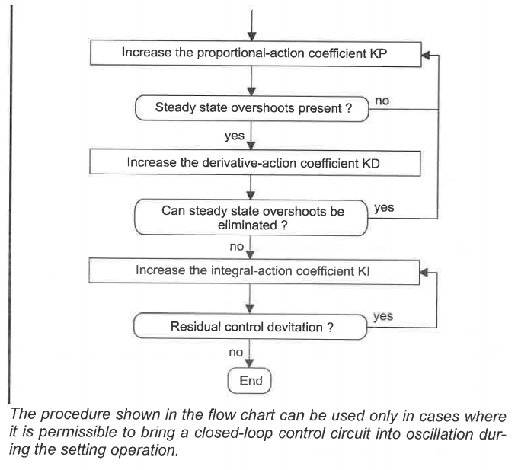

**TASK 1 – PROBLEM DESCRIPRION – BENDING MACHINE**

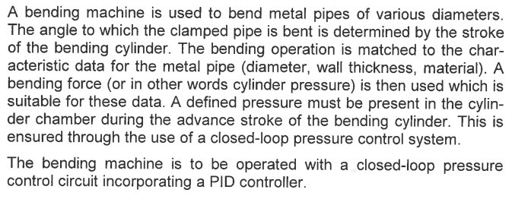

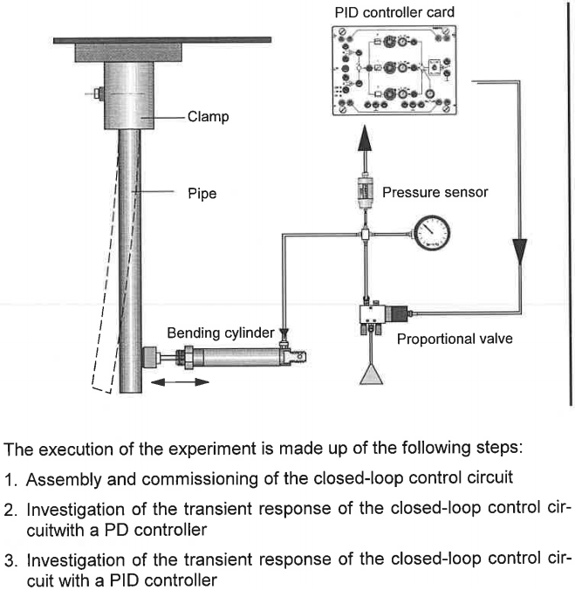

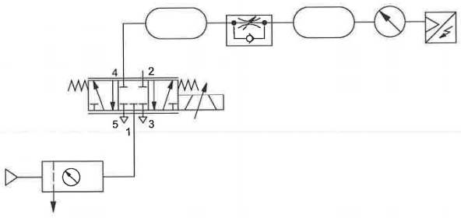

**Pneumatic Circuit**

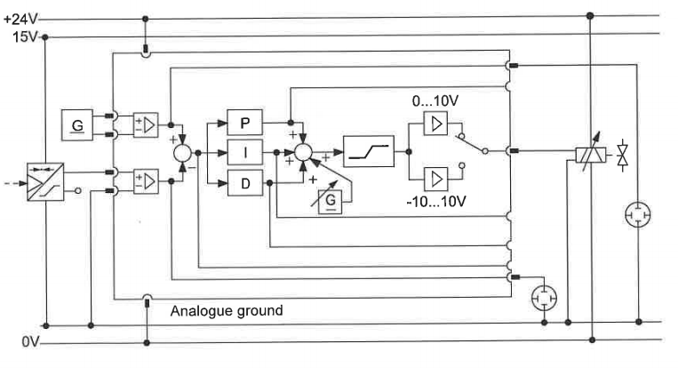

**Electrical Circuit**

**INVESTIGATION OF THE TRANSIENT RESPONSE WITH A PD CONTROLLER**

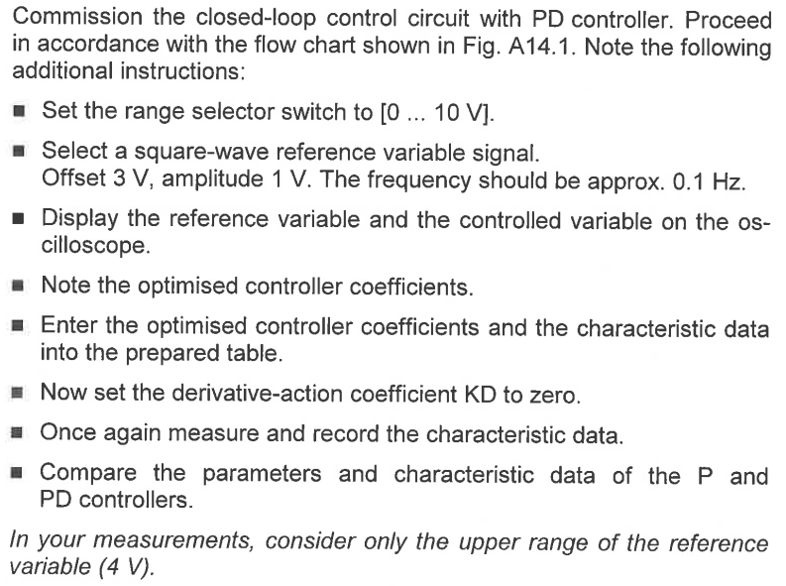

**INVESTIGATION OF THE TRANSIENT RESPONSE WITH A PID CONTROLLER**

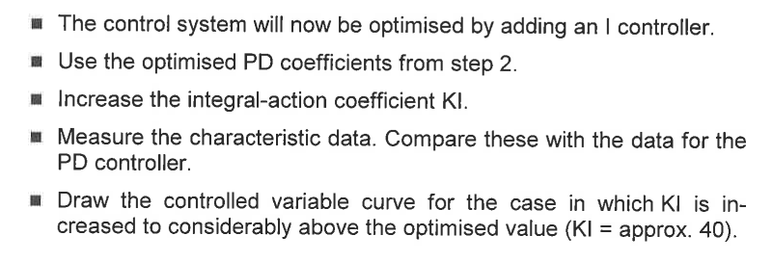

**BASICS OF ZIEGLAR-NICHOLS METHOD**

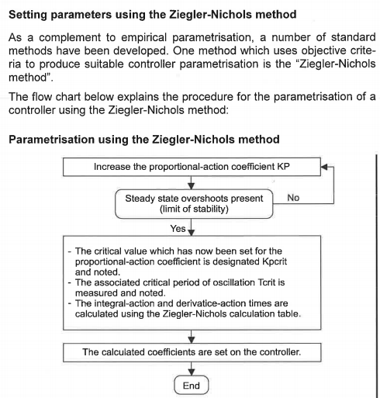

**TASK 2 – PROBLEM DESCRIPTION – TESTING MACHINE**

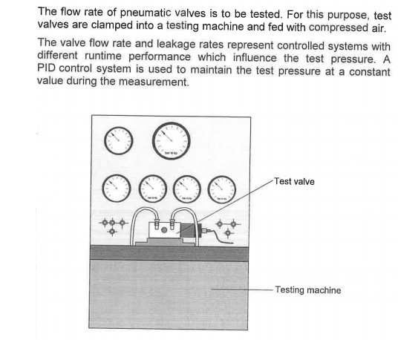

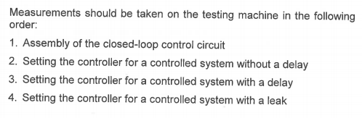

**ASSEMBLY OF CLOSED LOOP CONTROL CIRCUIT**

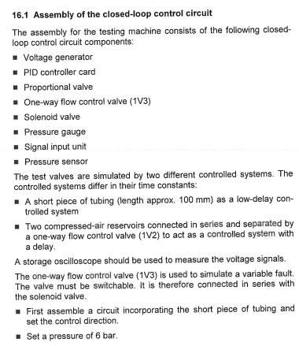

**SETTING OF CONTROLLER FOR A CONTROLLED SYSTEM WITHOUT DELAY**

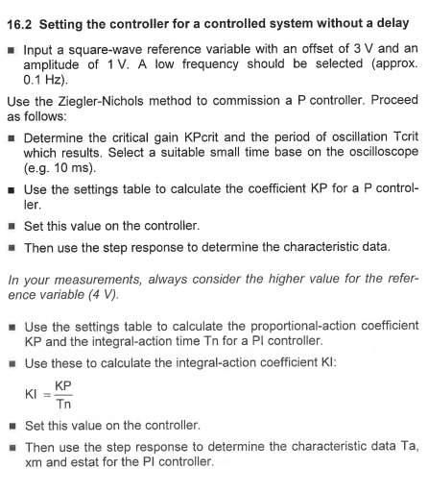

**SETTING OF CONTROLLER FOR A CONTROLLED SYSTEM WITH DELAY**

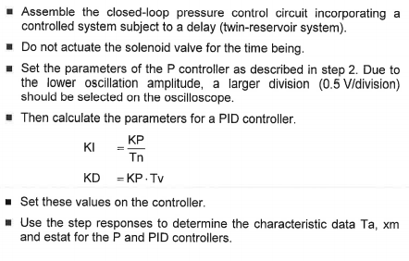

**SETTING OF CONTROLLER FOR A CONTROLLED SYSTEM WITH A LEAK**

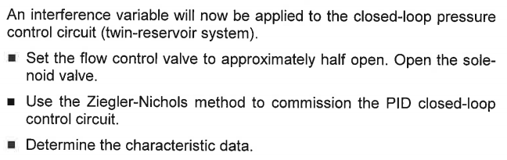

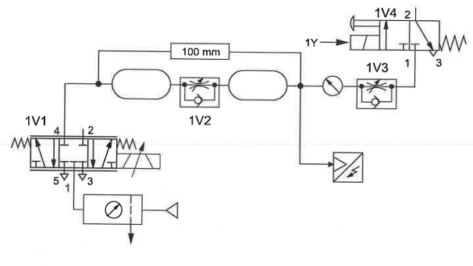

**Pneumatic Circuit Diagram**

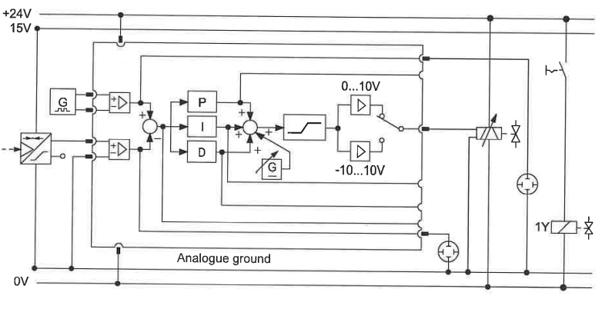

**Electrical Circuit Diagram**

**EXERCISE TASKS**

**Task 1: Investigation of the Transient Response of the closed loop control circuit using a PID controller**

|  |  |
| --- | --- |
|  |  |
| **Pneumatic Circuit** | **Electrical Circuit** |

* Fill in the entries of the table below:

|  |  |  |  |
| --- | --- | --- | --- |
| **Characteristic Data** | **Controller** | | |
| **P** | **PD** | **PID** |
| Proportional-action coefficient KP | 3 | 11 | 10.5 |
| Integral-action coefficient KI | 0 | 0 | 0.1 |
| Derivative-action coefficient KD [ms] | 0 | 1000 | 1000 |
| Settling Time Ta [ms] | 3225 | 884 | 873 |
| Overshoot Amplitude xm [mV] | 390 | 0 | 0 |
| Steady-state system deviation estate[mV] | 30 | 0 | 0 |

|  |
| --- |
|  |
| **P-Controller** |
|  |
| **PD-Controller** |
|  |
| **PID-Controller** |

* **Is the closed-loop control circuit still stable after the derivative action coefficient KD is switched off in the PD controller implementation?**

***Ans:*** *The transient response of the simulated closed loop system was unstable and oscillated before attaining steady state value. For a real system, a simple P-controller would either leave a finite steady error (if gain is a small value) or oscillate (for a larger gain) by driving the final control element from one direction to the other.*

* **Which type of controller gives the smallest overshoot amplitude. Justify why?**

***Ans:*** *In terms of overshoot, both PD and PID controllers were able to produce zero-overshoot in simulation. It is evident that since the simulated system doesn’t exhibit any damping or disturbance, the integral controller is not very necessary, just a simple PD-controller is able to achieve similar performance. However, practical elements will exhibit such characteristics and hence PID controller will be more desirable in such cases.*

**Task 2: Setting the Controller for a Controlled System**

|  |  |
| --- | --- |
|  |  |
| **Pneumatic Circuit** | **Electrical Circuit** |

|  |  |  |  |
| --- | --- | --- | --- |
| **Characteristic Data** | **Controller** | | |
| **P** | **PI** | **PID** |
| Proportional-action coefficient KP | 5 | 5 | 15.6 |
| Integral-action coefficient KI | 0 | 535 | 3.9 |
| Derivative-action coefficient KD | 0 | 0 | 15.6 |

|  |  |
| --- | --- |
|  |  |
| **P-Controller [Without Leak]** | **P-Controller [With Leak]** |
|  |  |
| **PI-Controller [Without Leak]** | **PI-Controller [With Leak]** |
|  |  |
| **PID-Controller [Without Leak]** | **PID-Controller [With Leak]** |

* **Which controller gave the better result for the system with and without leak? State the reason.**

***Ans:*** *The PID controller with the given set of gains was the most efficient in controlling the system with and without leak. The P-controller, although looks good in simulation, is not recommended in practical applications, owing to its nature of either leaving a steady-state error (for lower gain) or producing oscillations (for higher gain). The integral gain of PI controller was very high, which forced the system to overcompensate for the accumulated error, thereby swinging back and forth the setpoint – the behaviour got even worse with leakage. The PID controller had a similar response to that of the simple P controller, however, it is practically more robust than the P controller alone as it can dampen the oscillations and take action on accumulated error to improve steady-state performance. Furthermore, with proper tuning of the gains, the response of PID controlled system can be improved greatly.*

**DELIVERABLES**

* Filling of table fields and descriptive answers for the questions under each task.

**LAB SESSION SCREENSHOTS**

**Task 1:**

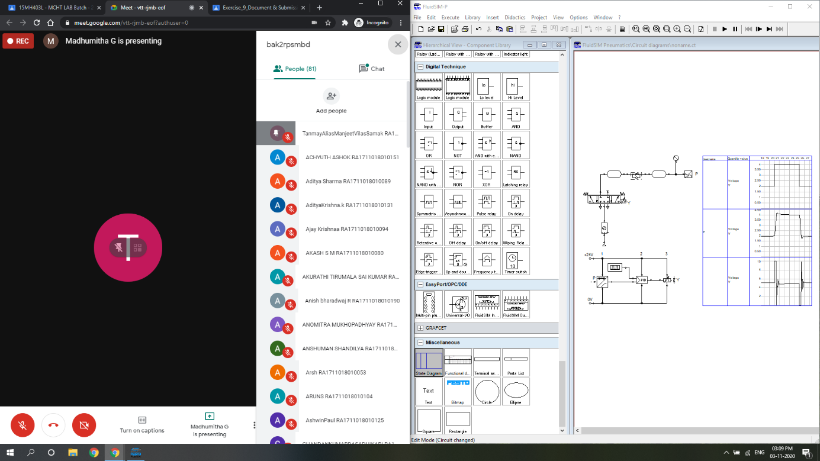

**Task 2:**

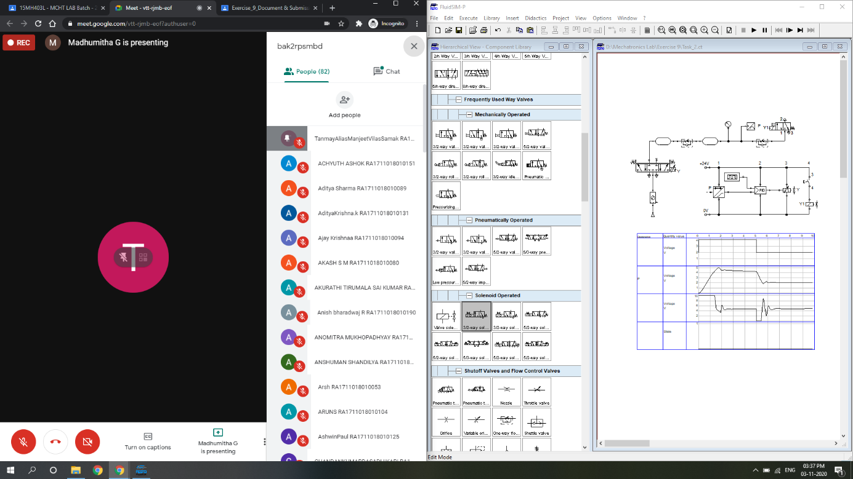

**INFERENCE**

The working of a proportional valve (introduced in the last experiment) was studied/revised from both theoretical and practical viewpoints. A closed loop electro-pneumatic circuit to control the pressure of a twin accumulator system (resembling bending and valve testing machine setups) was constructed and simulated using Festo FluidSIM.

The voltage setpoint to the solenoid of the proportional DCV was a square wave of frequency = 0.1 Hz, amplitude = 1 V, and offset = 3 V, to control the system pressure. The signal generator voltage (input) was not directly comparable against the system pressure as the physical units of these two quantities were not identical. Nonetheless, the analog pressure sensor output in terms of voltage was directly comparable against the signal generator voltage, since the two had same voltage scale.

The theory of PID controller was understood and a simulated PID controller card was used to regulate the system pressure in the aforementioned tasks. The effect of proportional, integral and derivative gains (, and ) was analysed by observing the transient response of the controlled variable (pressure).

For task 1, the controller gains were tuned to get minimum (or no) overshoot, minimum steady-state error and quick settling time for P, PD and PID controllers. For task 2 on the other hand, the given controller gains we fed into the simulated PID controller card and the system response was observed in each case (P, PI and PID controllers). Finally, the results were reported along with the corresponding state diagrams for signal generator (setpoint) and pressure sensor voltages.